**Description of the signature comparison method**

The system compares two signatures by calculating the distance between signatures feature vectors in Euclidean space. In order to extract feature vectors from each signature image a special neural net was trained.

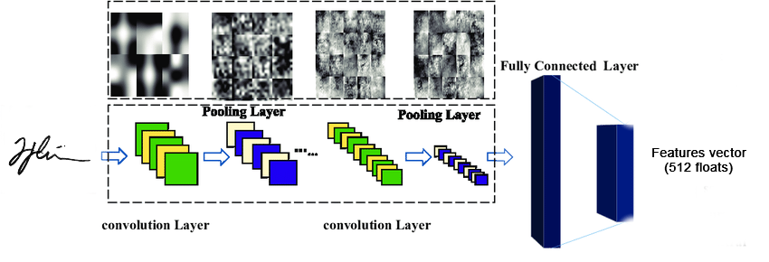

This neural network takes as input an image of a signature and produces as output a set of features that describe that signature in 512-dimensional space ( a vector of 512 floats). So, having representations of each signature as a 512-dimensional vector, the system performs pairwise calculation of the distance between two vectors in Euclidean space. Accordingly, the closer these 512-dimensional vectors (describing the signatures) are to each other in Euclidean space, the more similar the images of the signatures will look according to the neural network.

So, a lower distance indicates a higher confidence score (similarity) between the signatures, while a higher distance indicates less confidence score (similarity).

Distance Interpretation:

Distance ≤ 6.00: The signatures are considered a 100% match (they are highly similar).

Distance ≥ 10.00: The signatures are considered a 0% match (they are very different).

Distance between 6.00 and 10.00: The match percentage is scaled between 100% and 0%. For example, a distance of 8.00 would be interpreted as 50% confidence score (similarity) between 2 signatures.

Thresholds and Accuracy:

The current threshold values (6.00 and 10.00) were determined experimentally to work well in most cases.

Lowering the threshold (e.g., considering a distance of 5.00 as 100% match) could improve fake detection but might wrongly label genuine signatures written differently as fakes.

Increasing the threshold (e.g., considering a distance of 11.00 as 0% match) might make the system more tolerant to different ways of writing by the same person but could reduce its ability to detect fake signatures accurately.

In summary, the system uses distance values to determine how similar two signatures are, with specific thresholds to balance accuracy in detecting both genuine and fake signatures. Adjusting these thresholds can affect the system's performance in different ways.